**Software Requirements Specification**

**For**

**National Events, Cultural Events date time location Finder**

**Submitted to:**

**Dr. Kazi Masudul Alam**

**Associate Professor,**

**CSE Discipline, Khulna University.**

**Prepared by**

**Miss Rokeya Akter (160210)**

**&**

**Ferdousi Haque (160228)**

**01.08.2018**

***Page ii***

**Table of Contents**

**Table of Contents .......................................................................................................................... ii Revision History ...............................................................................** Error! Bookmark not defined.

### 1. Introduction ..............................................................................................................................1

1.1 Purpose ............................................................................................................................................ 1

1.2 Document Conventions .................................................................................................................... 1

1.3 Intended Audience and Reading Suggestions .................................................................................. 1

1.4 Product Scope .................................................................................................................................. 1

1.5 References ........................................................................................................................................ 1

### 2. Overall Description ..................................................................................................................2

2.1 Product Perspective ......................................................................................................................... 2

2.2 Product Functions ............................................................................................................................ 2

2.3 User Classes and Characteristics ..................................................................................................... 2

2.4 Operating Environment .................................................................................................................... 3

2.5 Design and Implementation Constraints .......................................................................................... 3

2.6 User Documentation ........................................................................................................................ 4

2.7 Assumptions and Dependencies ...................................................................................................... 4

### 3. External Interface Requirements ...........................................................................................4

3.1 User Interfaces ................................................................................................................................. 4

3.2 Hardware Interfaces ......................................................................................................................... 4

3.3 Software Interfaces .......................................................................................................................... 4

3.4 Communications Interfaces ............................................................................................................. 5

### 4. System Features ........................................................................................................................5

4.1 System Feature 1 .............................................................................................................................. 5

4.2 System Feature 2 …………….......................................................................................................... 6

4.3.Use cases description……………………………………………………………………………….6

### 5. Other Nonfunctional Requirements .......................................................................................12

5.1 Safety Requirements ........................................................................................................................ 12

5.2 Security Requirements ..................................................................................................................... 13

5.3 Software Quality Attributes ............................................................................................................. 13

Revision History

|  |  |  |  |
| --- | --- | --- | --- |
| **Name** | **Date** | **Reason For Changes** | **Version** |
| SRC on NCEF version 1.0 | 5/9/2018 | Few Use case description | version 1.0 |
| SRC on NCEF version 1.1 | 12/9/2018 |  |  |

# 1 Introduction

## 1.1 Purpose

We will describe a product named National events, Cultural Events date time location finder in this document. The scope of the product is among Khulna city. It is one part of the smart City system.

## 1.2 Document Conventions

This document uses the following conventions.

|  |  |
| --- | --- |
| DB | Database |
| ER | Entity Relationship |
| KCC | Khulna City Corporation |

## 1.3 Intended Audience and Reading Suggestions

This product is a prototype for event finder system and it is restricted within Khulna city. This project is useful for KCC and as well as to the citizens. The document is intended for KCC, users and citizens.

## 1.4 Product Scope

The purpose of the event finder system is to create an event by KCC and to find the events KCCording to the event’s date, time location and easy-to-use application for users. The other objectives and goals are

* KCC will be able to insert the list of guests.
* KCC will also be able to update and delete their events.

## 1.5 References

* [https://docs.google.com/spreadsheets/d/1KTn7hKx7eDI_5enyCP9r2Zxv4rHbfzcvStapub1W9Q/edit#gid=660185579L](https://docs.google.com/spreadsheets/d/1KTn7hKx7eDI_5enyCP9r2Zx-v4rHbfzcvStapub1W9Q/edit#gid=660185579L)
* <https://web.cs.dal.ca/~howkey/3130/src_template-ieee.doc>
* <https://www.tutorialspoint.com/software_engineering/software_requirements.html>

# 2 Overall Description

## 2.1 Product Perspective

The event finder system stores the following information

* Event_details
* Citizen / User_Descrptions  KCC / Admin Descriptions.

## 2.2 Product Functions

The major features of database system as shown below.

## 2.3 User Classes and Characteristics

Users of the system should be able to retrieve event information where, when, and how long the event will hold from the database. The system will support two types of user privileges. Citizens and Admin. Citizens will have KCCessed to citizen’s functions, and admin will have KCCessed to both Citizen and event management functions.

The citizen and admin should be able to do the following functions:

1. Citizen type account can be created
2. Admin type account can be created
3. Citizen profile can be updated
4. Admin profile can be updated
5. No account can not be deleted
6. Any profile will be publicly accessible
7. Admin can post for events
8. Citizen can search for events date
9. Citizen can search for events time
10. Citizen can search for events location
11. Citizen can mark if he/she is interested or going or may go
12. Citizen can rate events and also submit feedback.
13. Admin can also rate events
14. Any profile update should be after login
15. Admin can insert event date
16. Admin can insert event time
17. Admin can insert event location
18. Admin can insert the list of guests
19. Admin can update the events details
20. Admin can delete the events details
21. Admin can view Feedback given by customer.
22. Admin can add new admin.
23. Admin and Citizen can fill out a survey about the website.

There are a number of event which held at different locations on different dates and time.

## 2.4 Operating Environment

Operating environment for the events finder system is as listed below:

* Database
* Operating system: Windows 10
* Platform: .net
* Software: Visual Studio 2017

## 2.5 Design and Implementation Constraints

1. SQL commands for queries/applications
2. Implement the database at least using a centralized database management system

## 2.6 User Documentation

*As the system is not completed yet, so user documentation cannot be made.*

## 2.7 Assumptions and Dependencies

*Let us assume that*

* *During the bad climate, the event may postponed in that case, citizen may get wrong information*
* *For any reasons, the event may not begin timely.*
* *Database server errors may occur.*

## 3.1 User Interfaces

* *Front-end software: .net*
* *Back-end software: SQL*

## 3.2. Hardware Interfaces

* Windows 10
* A browser which supports CSS, HTML

## 3.3. Software Interfaces

Following are the software used for the events finder system application

|  |  |
| --- | --- |
| **Software used** | **Description** |
| Operating system | We have chosen Windows operating system for its best support and user-friendliness |
| Database | To save the events details we have chosen SQL database. |
| .Net | To implement the project we have chosen .Net language for its more interactive support. |

## 3.4. Communications Interfaces

The project will support all types of web browser.

# 4. System Features

The event finder system maintains information on different types of events time date, location etc.

### 4.1. System Features for Admin

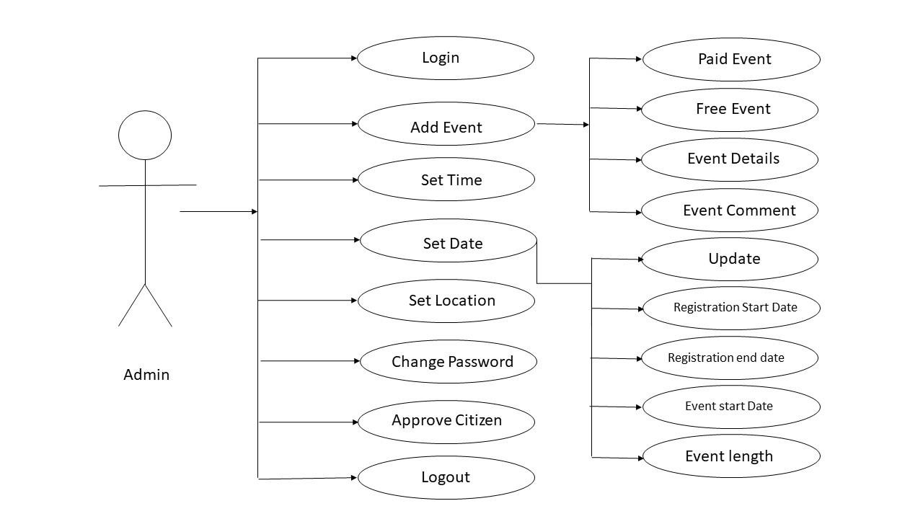

### 4.2. System Features for Citizen

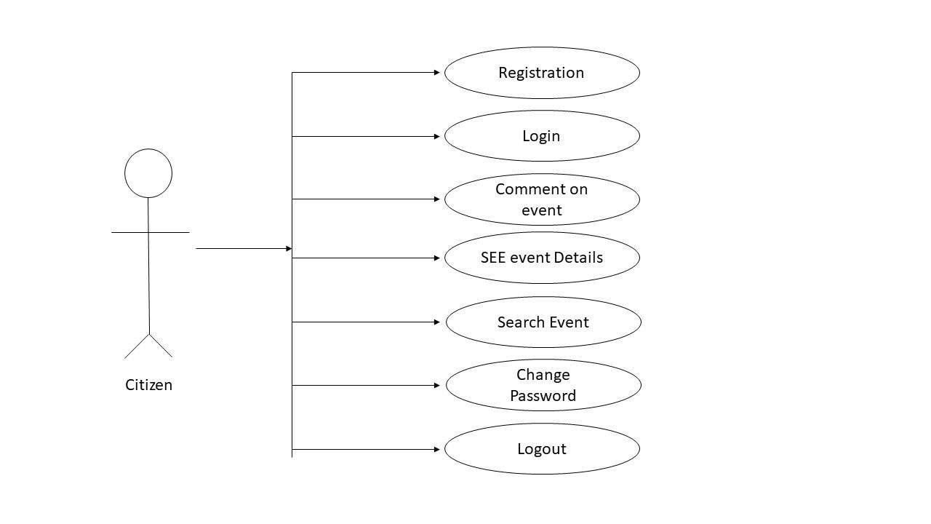

4.3.Use cases description

4.3.1.Home Page

|  |  |
| --- | --- |
| **Use Case Name:** | Home page |
| **Brief Description:** | The web server is waiting on to connect. |
| **Priority** | Essential |
| **Trigger** | User select the link on the KCC home page |
| **Precondition** | User is connected to the internet and on the KCC home page. |
| **Basic Path** | The server presents the home page. |
| **Alternate Path** | N/A |
| **Post condition** | User is on the home page. |
| **Exception Path** | If there is a connection failure, the Server returns to the wait state. |

4.3.2. Fill out the Survey

|  |  |
| --- | --- |
| **Use Case Name:** | Survey |
| **Brief Description:** | This operation permits user to fill out a survey. |
| **Priority** | Essential |
| **Trigger** | User choose to fill out a survey |
| **Precondition** | User are connected to the internet and on the Home Page. |
| **Basic Path** | 1. The Server presents the user with a form.  2. User fill in the form and click submit or press Enter  3. The Server checks to see if all required fields are not empty.  4. If the required fields are not empty, the  Server creates a new record  in then Survey Table of the User  Database.  5. If any of the required fields are empty,  the Server returns a  message and returns the User to the  Survey form.  6. The Server returns to the Admin Home Page |
| **Alternate Path** | N/A |
| **Post condition** | The survey record is created in the Survey Table of the Database. |
| **Exception Path** | If the connection is terminated before the form is submitted, the fields are all cleared and the Server is returned to the wait state. |

4.3.3 Create a Profile

|  |  |
| --- | --- |
| **Use Case Name:** | Create a Profile |
| **Brief Description:** | This operation permits to create a Profile. |
| **Priority** | Essential |
| **Trigger** | Anyone choose to create a new profile on the Home page. |
| **Precondition** | He/She must be connected to the Internet and on the KCC Home page |
| **Basic Path** | 1. He/she click on add a new profile. 2. The Server returns a form. 3. He fill in the form and click *submit* or press enter. 4. The Server checks to see if any required field is empty. 5. If any required field is empty, the Server will send a message and return a new entry form page. 6. If no required field is empty, the Server will create a new record in the Event Finder Database. 7. He may select Cancel. 8. If he select Cancel, the form is cleared and Admin are returned to the KCC Admin Home page. |
| **Alternate Path** | N/A |
| **Post condition** | A record is created in the Admin/Citizen Table of the Event Finder Database. |
| **Exception Path** | 1. If the connection is terminated before the form is submitted, the fields are cleared and the Server is returned to the wait state. 2. If the connection is terminated after the form is submitted, but before he is returned to the KCC Home Page, the record is created of the Event Finder Database. |

**4.3.4. Update a Profile**

|  |  |
| --- | --- |
| **Use Case Name:** | Update an Profile |
| **Brief Description:** | This operation permits Admin/User to update an existing Profile in the Event Finder Database. |
| **Priority** | Essential |
| **Trigger** | Admin/User choose to update an existing Profile in the Database. |
| **Precondition** | Admin/User must be connected to the Internet, logged in and on the KCC Home page |
| **Basic Path** | 1. The Admin/User clicks on update profile option.  2. The Server returns profile information in it and a message to update the data they wish and click submit or press Enter 3. The Server replaces the old data with the new data and returns the Admin/User to the KCC Home Page. |
| **Alternate Path** | N/A |
| **Post condition** | The record in the Admin Table of the Database has been updated and the Admin is returned to the KCC Admin Home Page. |
| **Exception Path** | 1. If the connection is terminated before the form is submitted, the fields are cleared and the Server is returned to the wait state. 2. If the connection is terminated after the form is submitted, but before Admin are returned to the KCC Admin Home Page, the record is created in the Event Table of the Event Finder Database. |

4.3.5. Create a new Event

|  |  |
| --- | --- |
| **Use Case Name:** | Create a new Event |
| **Brief Description:** | This operation permits admin to create a new event on the Home page |
| **Priority** | Essential |
| **Trigger** | Admin choose to create a new event on the Home page. |
| **Precondition** | Admin must be connected to the Internet , logged in and on the KCC Home page |
| **Basic Path** | 1. Admin click on add a new entry. 2. The Server returns a form. 3. Admin fill in the form and click *submit* or press enter. 4. The Server checks to see if any required field is empty. 5. If any required field is empty, the Server will send a message and return Admin to the new entry form page. 6. If no required field is empty, the Server will create a new record in the Event Table in the Event Finder Database, and return Admin to the KCC Admin Home Page. 7. Admin may select Cancel. 8. If Admin select Cancel, the form is cleared and Admin are returned to the KCC Admin Home page. |
| **Alternate Path** | N/A |
| **Post condition** | A record is created in the Event Table of the Event Finder Database. |
| **Exception Path** | 1. If the connection is terminated before the form is submitted, the fields are cleared and the Server is returned to the wait state. 2. If the connection is terminated after the form is submitted, but before Admin are returned to the KCC Admin Home Page, the record is created in the Event Table of the Event Finder Database. |

4.3.6. Update an Event

|  |  |
| --- | --- |
| **Use Case Name:** | Update an Entry |
| **Brief Description:** | This operation permits Admin to update an existing entry in the Event Finder Database. |
| **Priority** | Essential |
| **Trigger** | Admin choose to update an existing entry in the Database. |
| **Precondition** | Admin must be connected to the Internet, logged in and on the KCC Home page |
| **Basic Path** | 1. The Admin clicks on update an event. 2. The Server returns a form to choose an event by drop down menu.  3. The Server returns a form with the data for that Event in it and a message to update the data they wish and click submit or press Enter 4. The Server replaces the old data with the new data and returns the Admin to the KCC Admin Home Page. |
| **Alternate Path** | N/A |
| **Post condition** | The record in the Event Table of the Database has been updated and the Admin is returned to the  KCC Admin Home Page. |
| **Exception Path** | 1. If the connection is terminated before the form is submitted, the fields are cleared and the Server is returned to the wait state. 2. If the connection is terminated after the form is submitted, but before Admin are returned to the KCC Admin Home Page, the record is created in the Event Table of the Event Finder Database. |

4.3.7. Search an Event

|  |  |
| --- | --- |
| **Use Case Name:** | Search an Event |
| **Brief Description:** | This operation permits the Admin/User to search for the information. |
| **Priority** | If time permits. |
| **Trigger** | The User/Admin chooses to search. |
| **Precondition** | User/Admin must be connected to the Internet, logged in and on the KCC Home page |
| **Basic Path** | 1. A search bar will be seen by an Admin or User.  2. They search according their will.  3. Then they click on Search or press Enter.  4. The Server returns the information and back to the Home page. |
| **Alternate Path** | N/A |
| **Post condition** | The User/Admin receives the information or he is returned to the KCC Home Page. |
| **Exception Path** | 1. If the connection is terminated before the information is returned, the Server is returned to the wait state. 2. If the connection is terminated after the information is returned, the Server is returned to the wait state |

**4.3.8. Delete an Event**

|  |  |
| --- | --- |
| **Use Case Name:** | Delete an Event |
| **Brief Description:** | This operation permits Admin to delete an event. |
| **Priority** | Essential |
| **Trigger** | Admin choose to delete an existing entry in the Database. |
| **Precondition** | Admin must be connected to the Internet, logged in and on the KCC Home page |
| **Basic Path** | 1. The Admin clicks on delete an event. 2. The Server returns a form to choose an event by drop down menu.  3. The Server returns a form with the data for that Event in it and a message to delete the event they wish and click delete or press Enter. 4. The Server delete the old data and returns the Admin to the KCC Admin Home Page. |
| **Alternate Path** | N/A |
| **Post condition** | The record in the Event Table of the Database has been deleted and the Admin is returned to the KCC Admin Home Page. |
| **Exception Path** | If the connection is terminated before the form is submitted, the fields are all cleared and the Server is returned to the wait state. |

**4.3.9. Submit Feedback**

|  |  |
| --- | --- |
| **Use Case Name:** | Submit Feedback |
| **Brief Description:** | This operation permits User to submit feedback about the event |
| **Priority** | Optional |
| **Trigger** | User choose to submit a Feedback about the event |
| **Precondition** | User must be connected to the Internet , logged in and on the KCC Home page |
| **Basic Path** | 1. User click on Feedback option. 2. The Server returns a box. 3. Admin fill in the box and click *submit* or press enter. 4. Admin may select Cancel. 5. If User select Cancel, the box is cleared and User is returned to the KCC Home page. |
| **Alternate Path** | N/A |
| **Post condition** | A record is created in the Feedback Table of the Event Finder Database. |
| **Exception Path** | 1. If the connection is terminated before the feedback is submitted, the fields are cleared and the Server is returned to the wait state. 2. If the connection is terminated after the feedback is submitted, but before User are returned to the KCC Home Page, the record is created in the Feedback Table of the Event Finder Database. |

**4.3.10. View Feedback**

|  |  |
| --- | --- |
| **Use Case Name:** | View Feedback |
| **Brief Description:** | This operation permits Admin to view the users feedback |
| **Priority** | Optional |
| **Trigger** | Admin choose to view the feedback |
| **Precondition** | Admin must be connected to the Internet , logged in and on the KCC Admin Home page |
| **Basic Path** | Admin click on the view feedback option and see the feedback |
| **Alternate Path** | N/A |
| **Post condition** | The User receives the information or he is returned to the KCC Home Page |
| **Exception Path** | If there is a connection failure, the Server returns to the wait state. |

**4.3.11. Add an Admin**

|  |  |
| --- | --- |
| **Use Case Name:** | Add an Admin |
| **Brief Description:** | This operation permits to add an admin |
| **Priority** | Essential |
| **Trigger** | Admin choose to add an admin |
| **Precondition** | Admin must be connected to the Internet , logged in and on the KCC Home page |
| **Basic Path** | 1. Admin clicks on add an admin.  2. All data from the database is returned from database and beside every data there is an option/check box to add as admin.  3. By clicking the check box and finally click on add option or press enter.  4. Admin may select Cancel.  8. If Admin select Cancel, the box is cleared and he is returned to the KCC Home page. |
| **Alternate Path** | N/A |
| **Post condition** | A record is updated. |
| **Exception Path** | If the connection is terminated before the form is submitted, the fields are all cleared and the Server is returned to the wait state. |

**4.3.12. Add a Citizen**

|  |  |
| --- | --- |
| **Use Case Name:** | Add an Citizen |
| **Brief Description:** | This operation permits to add a citizen |
| **Priority** | Essential |
| **Trigger** | Admin choose to add a citizen |
| **Precondition** | Admin must be connected to the Internet , logged in and on the KCC Home page |
| **Basic Path** | 1. Admin clicks on add a citizen.  2. All data from the database is returned from database and beside every data there is an option/check box to add as citizen.  3. By clicking the check box and finally click on add option or press enter.  4. Admin may select Cancel.  8. If Admin select Cancel, the box is cleared and he is returned to the KCC Home page. |
| **Alternate Path** | N/A |
| **Post condition** | A record is updated. |
| **Exception Path** | If the connection is terminated before the form is submitted, the fields are all cleared and the Server is returned to the wait state. |

# 5. Other Nonfunctional Requirements

## 5.1. Safety Requirements

If there is extensive damage to a wide portion of the database due to a disk crash. Therefore, admin should careful in this case.

## 5.2. Security Requirements

Security systems need database storage just like many other applications. However, The requirements of the security means that admin must choose their database partner carefully. In order to use certain features of the system, users must first authenticate themselves by  
name and password. The system shall not allow KCCess if the user fails to provide correct log  
in information .The system should automatically perform log out if the user has been idle for a specific period.

## 5.3. Software Quality Attributes

* **AVAILABILITY:** The event should be available on the specified date and specified time.
* **CORRECTNESS:** The event should start from correct start time.
* **MAINTAINABILITY:** The administrators should maintain correct schedules of events.
* Reliability**:** The software system could provide automatically generated backup (on external hard drives) containing all the stored information at the time the backup is taken. The system shall allow authorized users to restore the data from an existing backup.

**5.4.User Interface Requirements**

The user interface of the application must be user-friendly, intuitive and easy to use,

implementing the ergonomics standards.

**5.5.Performance Requirements**

The system shall function in real-time: any operation on the stored information, shall complete in less than 10 seconds.

The system shall allow simultaneous use by at least 100 users, without data corruption.